**Module-4: Auto Scaling Assignment**

**Problem Statement:**

You work for XYZ Corporation that uses on premise solutions and some limited number of systems. With the increase in requests in their application, the load also increases. So, to handle the load the corporation has to buy more systems almost on a regular basis. Realizing the need to cut down the expenses on systems, they decided to move their infrastructure to AWS.

**Tasks To Be Performed:**

1. Create a web server AMI with Apache 2 server running in it.

2. Create a launch configuration with this AMI.

3. Use this launch configuration to create an Auto Scaling group with 1 minimum and 3 maximum instances.

**Problem 1 Solution:** Create a web server AMI with Apache 2 server running in it.

**a. Create an EC2 Instance with Apache2 Web Server**

**Step 1: Go** tothe **“Services”** section& **search** the **“EC2”. Click** onthe **“Instances”** inthe **“EC2”** section.

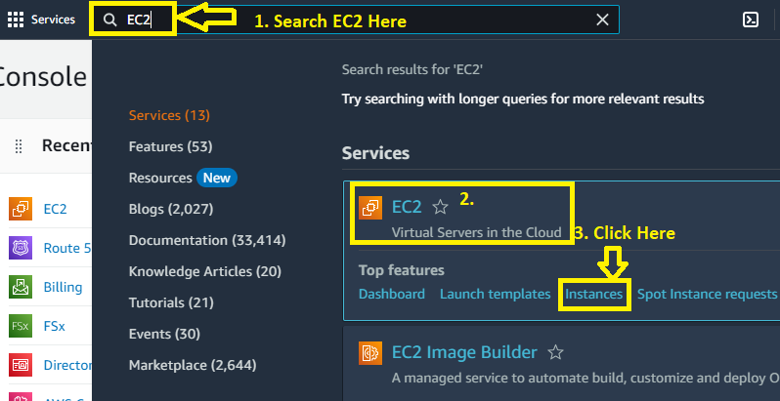

**Step 2: Click** on the **“Launch Instance”.**

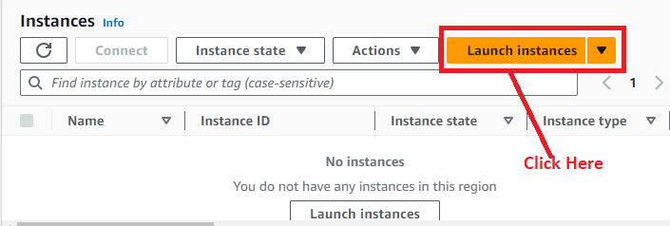

**Step 3: Choose** the **“Name”** as **“MyAutoScalingInstance”.**

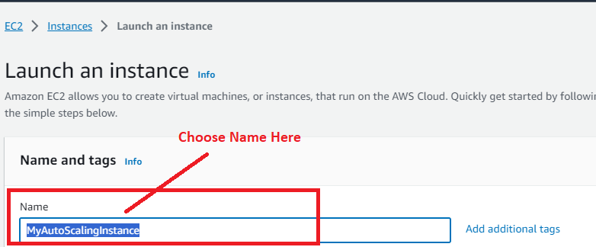

**Step 4: Choose** the **“Amazon Machine Image”** as **“Amazon Linux (AWS)”.**

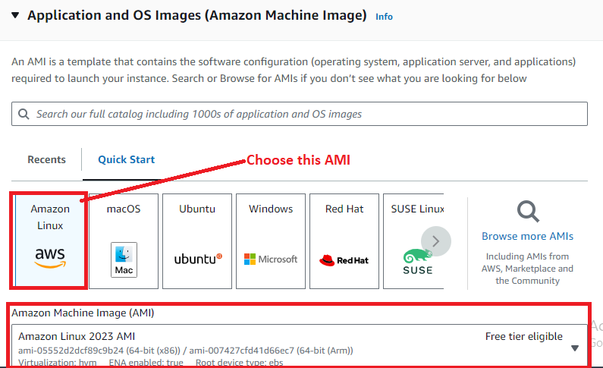

**Step 5: Choose** the **“Instance Type”** as **“t2.micro”.**

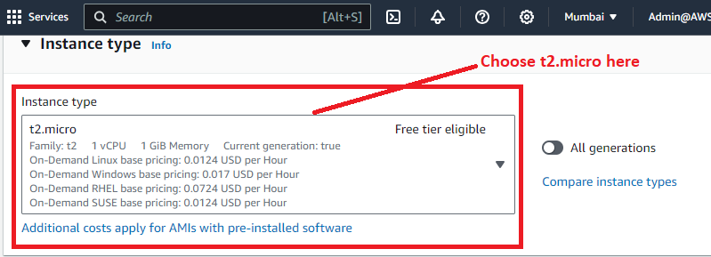

**Step 6: You** can **create** a **“Key pair (login)”** here**, we** have **created. So, we** will **choose “Key pair name –required”** as **“MY-WEB-SERVER”.**

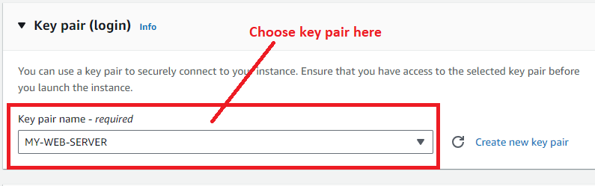

**Step 7: In** the **“Network Settings”, click** on the **“Edit”.**

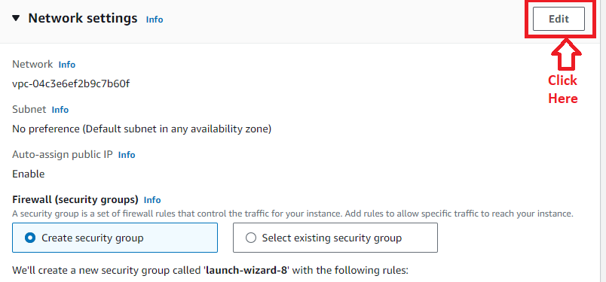

**Step 8: We** have **created lots of security group** in our **AWS account; we** will **choose “Select Existing Security group” option here. After selecting** the **option, choose** your **security group** here**.**

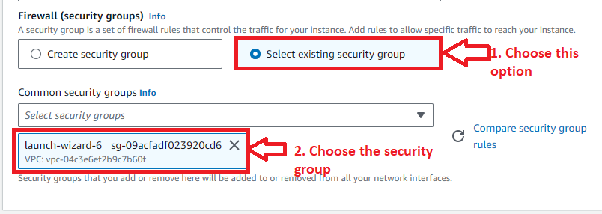

**Step 9: Go** tothe **“Advanced Details”** & **put** the **user data** for **installing** the **apache 2 server** here.

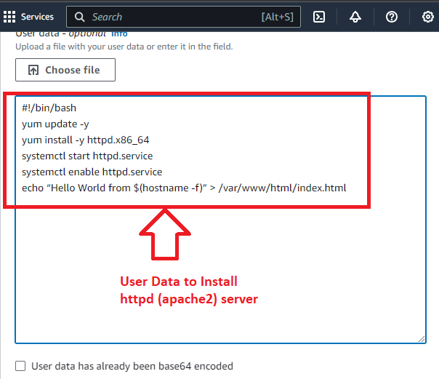

**Step 10: Click** onthe **“Launch Instance”.**

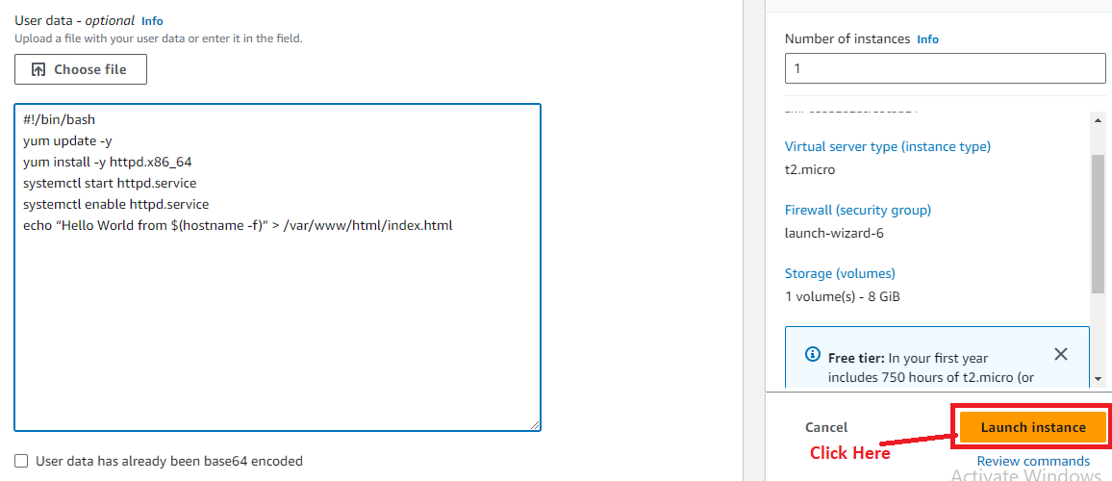

**Step 11: The instance** will be **successfully launched. Click** on the **“Hyperlink”** to **view** the **instance.**

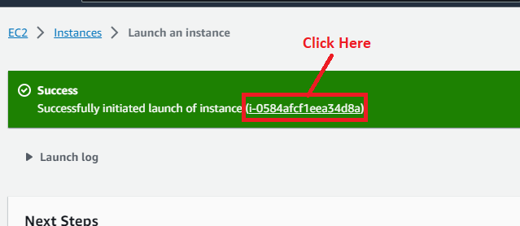

**Step 12: Your instance** will be shown **in** the **“Running”** state**.**

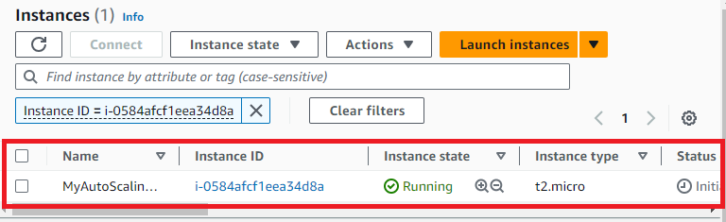

**Step 13: Now, select your instance** & **copy the IP Address.**

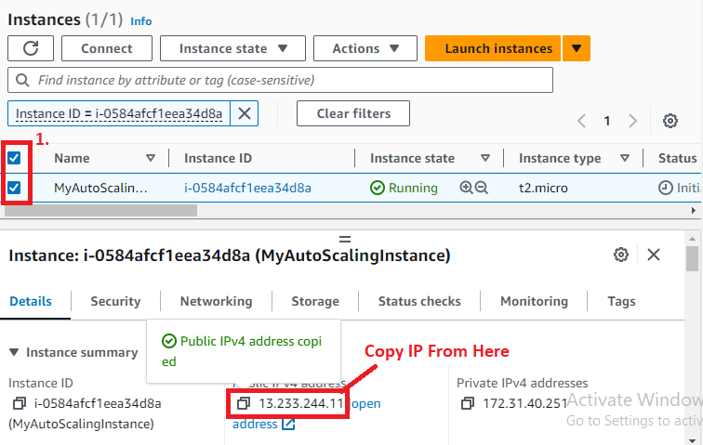

**Step 14: Paste** the **IP Address** in the **browser address bar** & **your apache 2 server** will be **successfully installed** & **running web page** will be **shown** with **data.**

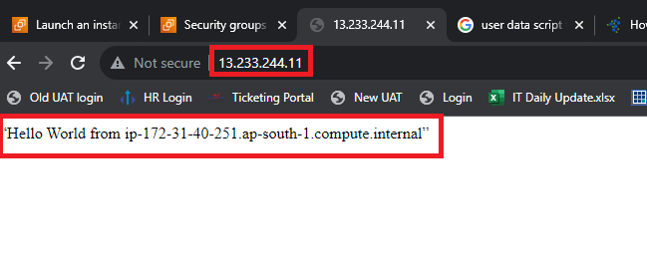

**b. Create an AMI of this Instance**

**Step 1: Select** the **Instance** & **Go** to **“Actions>Image and templates>Create image”.**

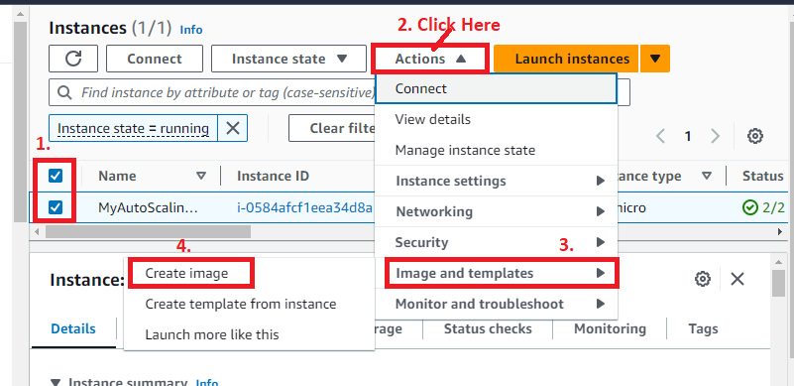

**Step 2: Choose** the **“Image name”** as **“MyFirstAutoScalingImage”.**

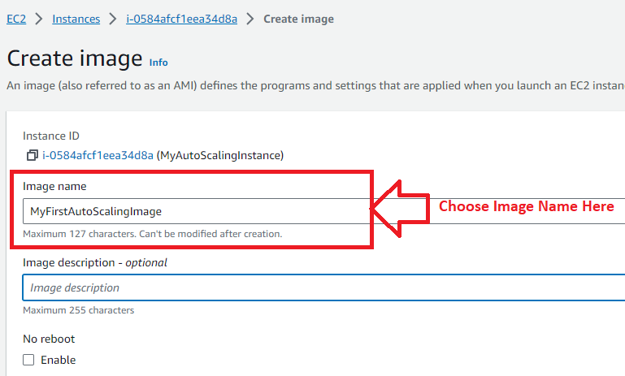

**Step 3: Your instance volume** will be **remaining same.**

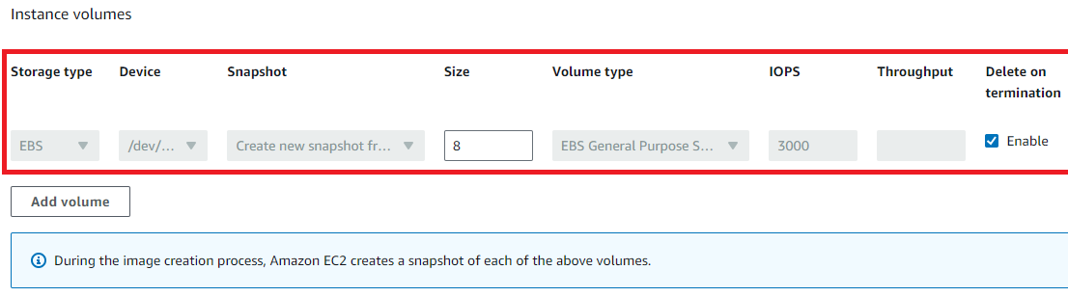

**Step 4: In** the **“Tags”** section**, choose** the **“Tag images and snapshots together”** option.

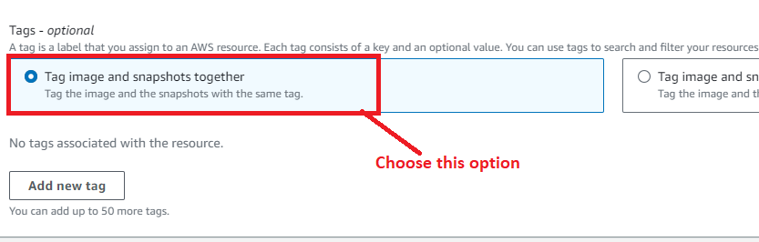

**Step 5: Click** onthe **“Create image”.**

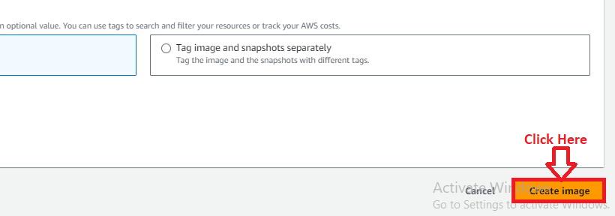

**Step 6: Your AMI** will be **started creating. A message** will be **shown** abovethe **EC2 instance.**

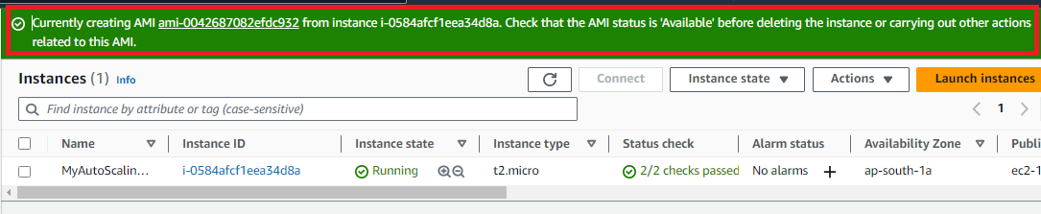

**Step 7: Click** onthe **“AMI hyperlink”** & **you** will be **redirected** to **AMI page.**

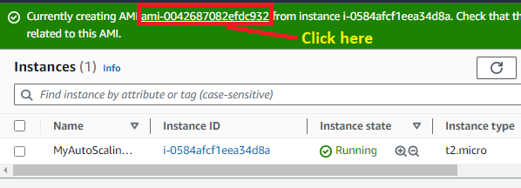

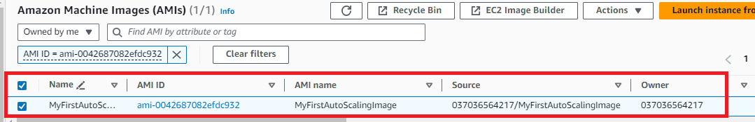

**Step 8: After 5-10 minutes, your AMI** will be **shown** in **“Available”** state**. It means, your AMI** has been **successfully created.**

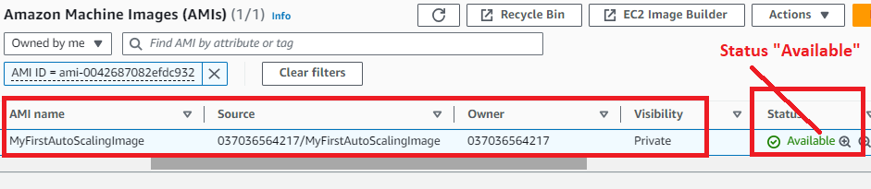

**Problem 2 Solution:** Create a launch configuration with this AMI.

**Step 1: In** the **“EC2”** section, **click** onthe **“Launch Templates”.**

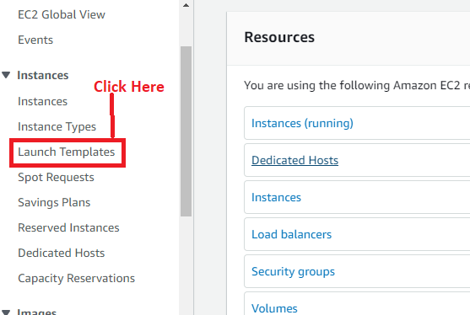

**Step 2: Click** onthe **“Create launch template”.**

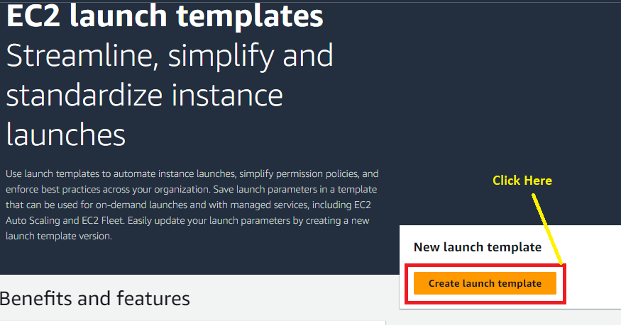

**Step 3: Choose** the **following details** herein **“Launch Template name and description”.**

**Launch template name – required:** MyFirstTemplateAutoScaling

**Template version description:** A template for auto scaling groups

**You** can also **enable Auto scaling guidance** option for **EC2 Auto Scaling.**

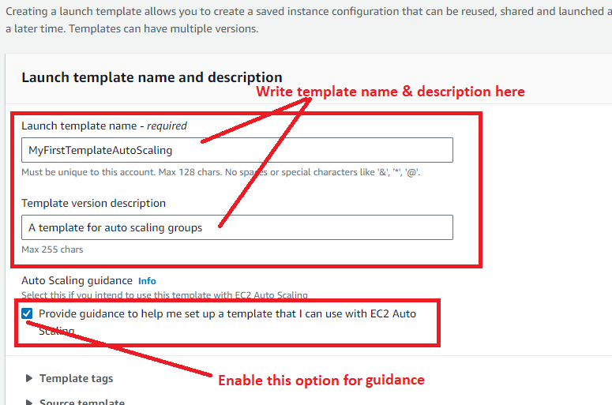

**Step 4: In** the **“Application and OS Images”, Go** to **“My AMI”. Choose** the **“Owned by Me”** option & your **Amazon Machine Images** will be **automatically selected, if you created it** for **first time.**

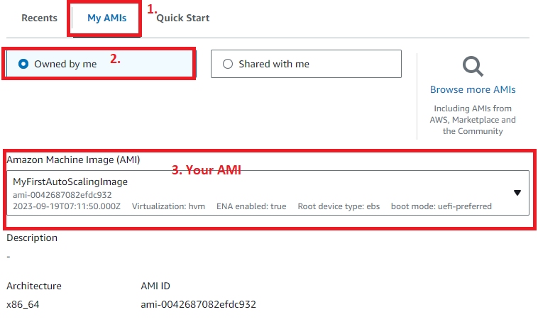

**Step 5: Choose** the **“Instance Type”** as **“t2.micro” & choose** the **“Key pair (login)”** as the **“MY-WEB-SERVER”.**

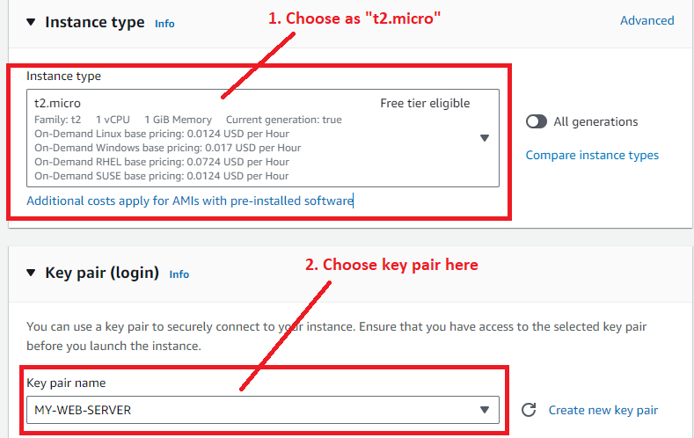

**Step 6: In** the **“Network Settings”, leave** the **“Subnet”** as **“Don’t include in launch template”.**

**While Choose** your **security group** in **“Firewall (security groups). Choose** the **option “Select existing security group”** & **choose** your **“Common security groups”** as **“launch-wizard-6 (your created security groups)”.**

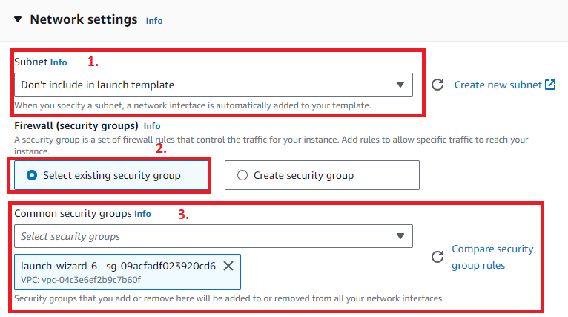

**Step 7: Click** onthe **“Create launch template”.**

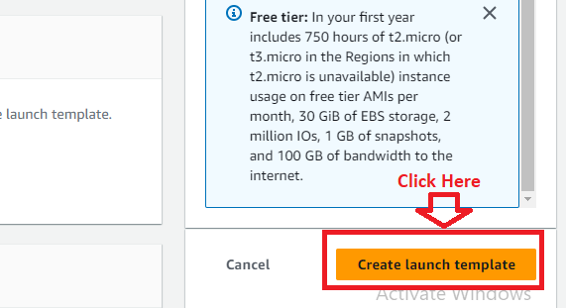

**Step 8: Your launch template** will be **successfully created. Click** onthe **“MyFirstAutoScalingImage” hyperlink.**

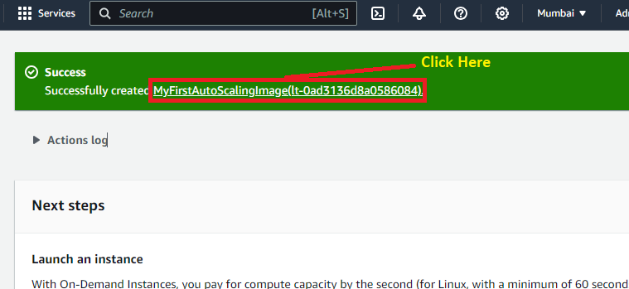

**Step 9: After clicking** on the **hyperlink, you** will **get** your **launch template details** here**.**

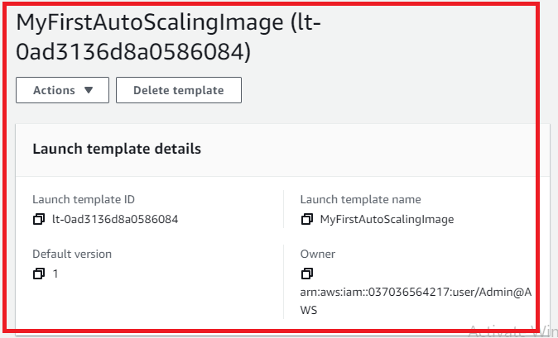

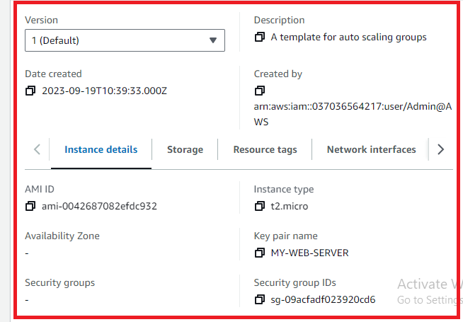

**Problem 3 Solution:** Use this launch configuration to create an Auto Scaling group with 1 minimum and 3 maximum instances.

**Step 1: Click** on the **“Auto Scaling Groups”** inthe **“EC2 Dashboard”.**

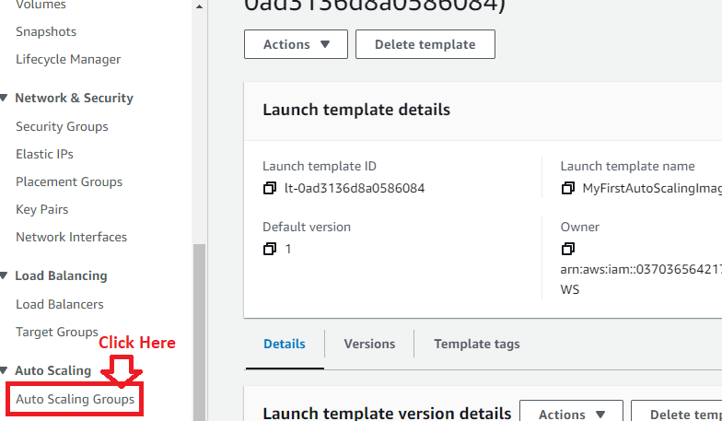

**Step 2: Click** on the **“Create Auto Scaling Group”.**

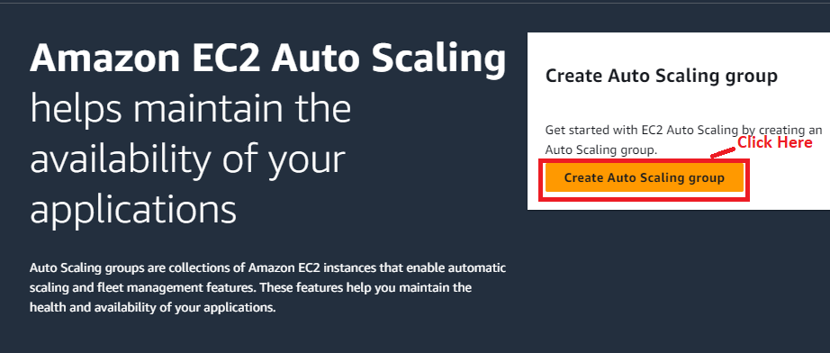

**Step 3: Choose** the **“Auto Scaling Group Name”** as **“MyFirstAutoScalingGroup”.**

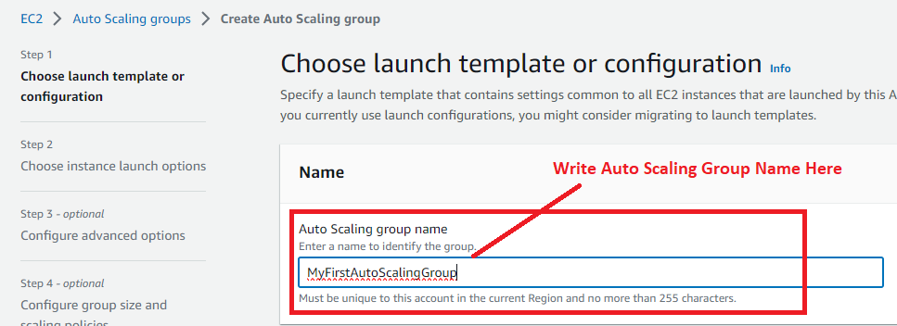

**Step 4: Choose** the **“MyFirstAutoScalingImage”** as a **“Launch Template”.**

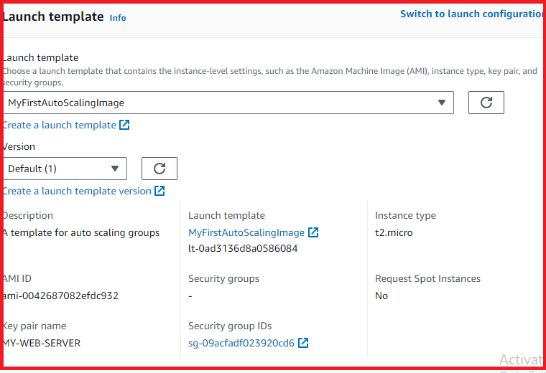

**Step 5: Click** onthe **“Next”.**

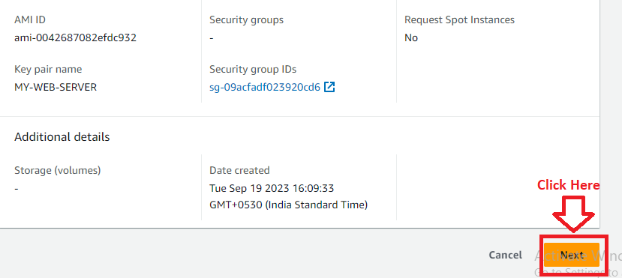

**Step 6: In** the **“Network”, choose** a **VPC** & **subnet here. We** will **leave** the **VPC** as **by default. Whereas subnet, we choose** as **“ap-south-1a”** & **“ap-south-1b”.**

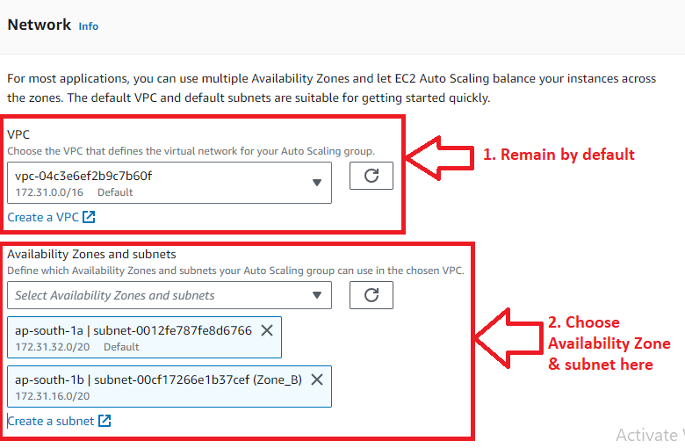

**Step 7: Click** on the **“Next”.**

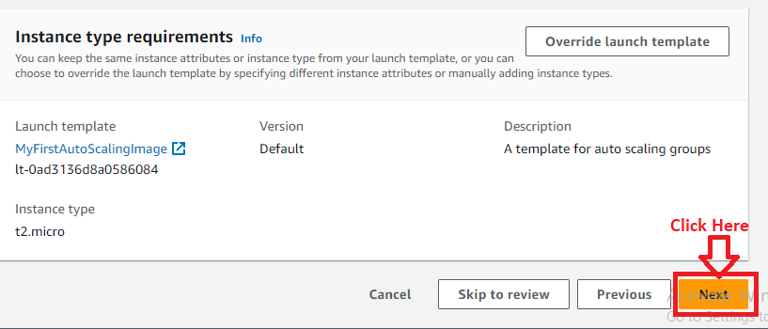

**Step 8: We don’t choose** any **load balancer** in **“Configure advanced options-optional”. Click** on the **“Next”** here**.**

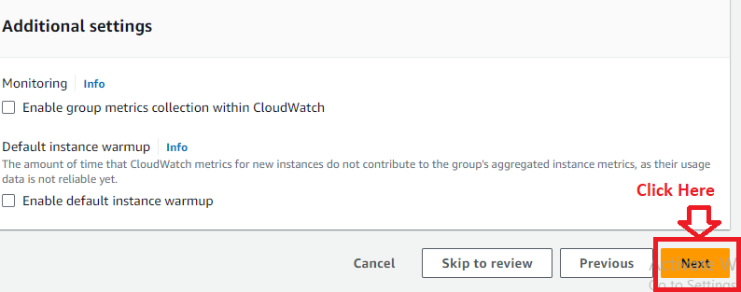

**Step 9: In** the **group size, choose minimum & maximum group you want to create. We choose “Minimum”** as **1 & “Maximum”** as **3.**

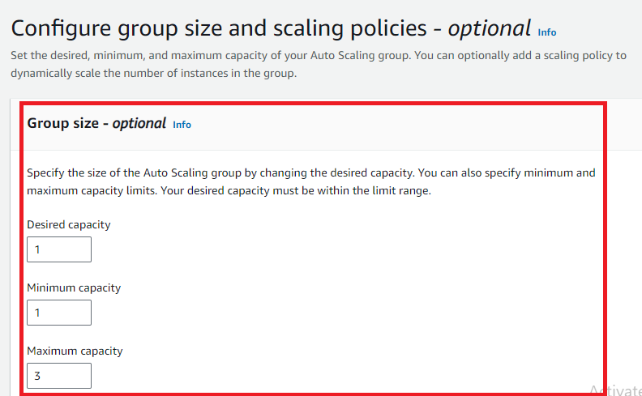

**Step 10: Choose “Scaling policies – optional”** as **“None”** & **click** on the **“Next”.**

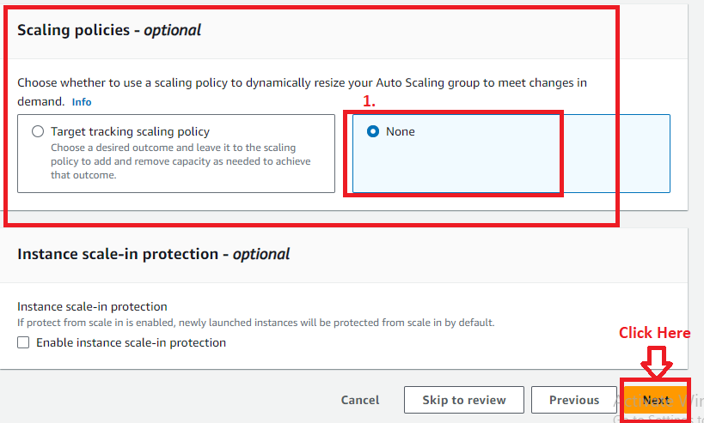

**Step 11: Click** onthe **“Next”** in **“Notifications” & “Tags”** section**. You** will go **to** the **“Review”** section**. You** can **review** your **settings** here **&** can **edit if any changes required.**

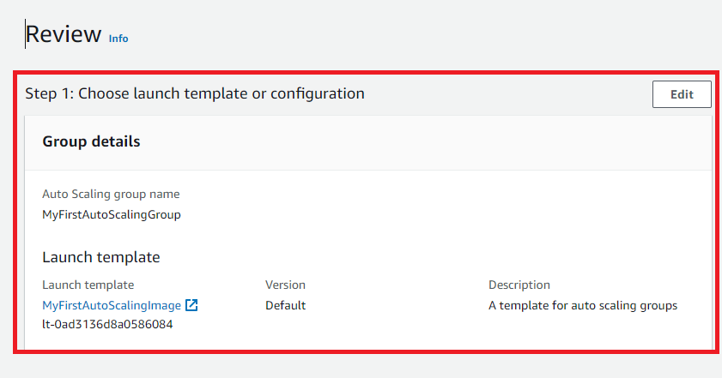

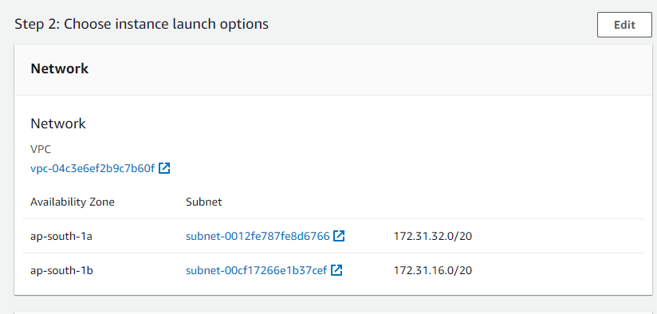

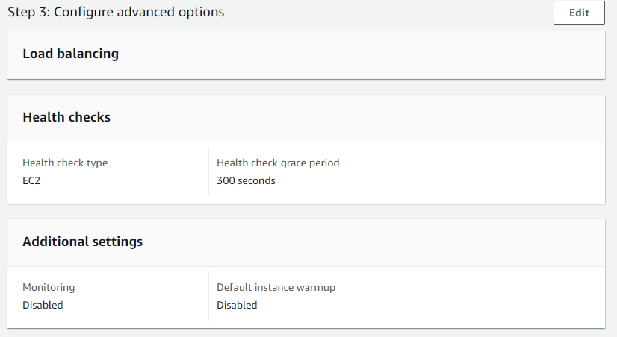

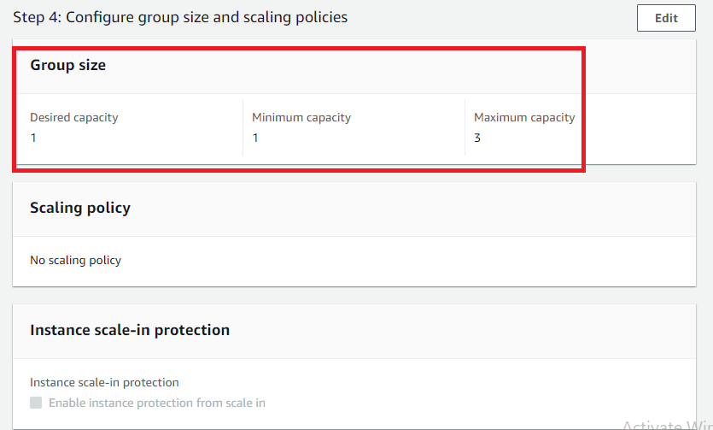

**Step 12: Click** onthe **“Create Auto Scaling group”.**

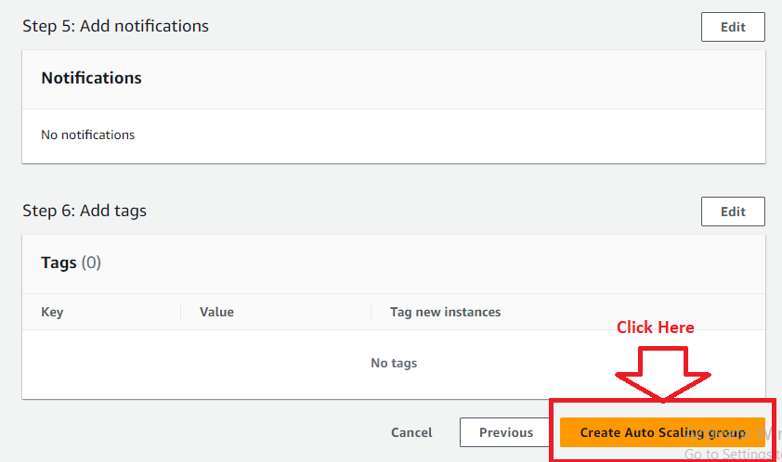

**Step 13: Your Auto Scaling group** will be **started creating & initially status** shown as **“Updating capacity..”**

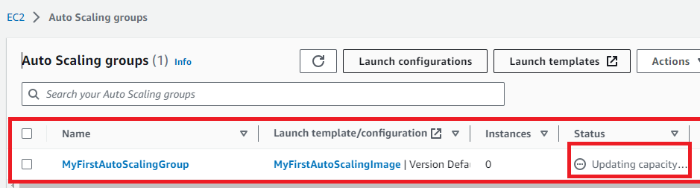

**Step 14: Select** your **Auto Scaling Group** & **go** to the **“Activity”. A single instance** will be **successfully launched** by **“Auto Scaling groups”** because **we** have **selected “Desired Capacity”** as **1.**

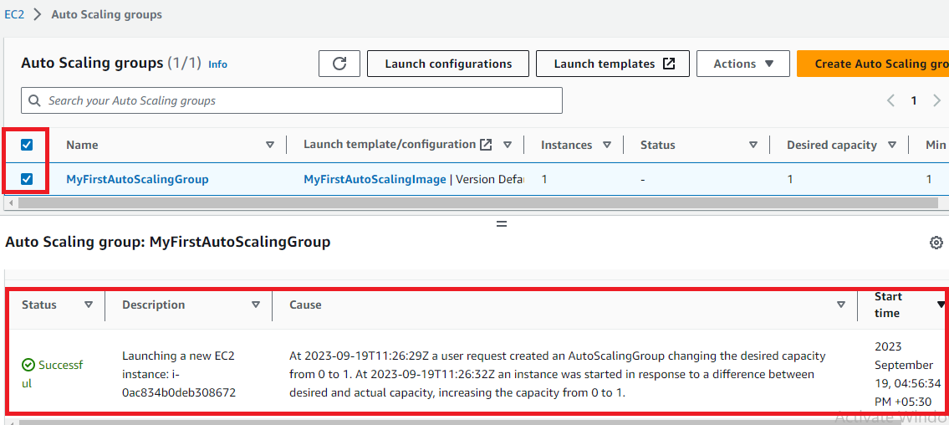

**Step 15: Go** tothe **“EC2 Dashboard”.**

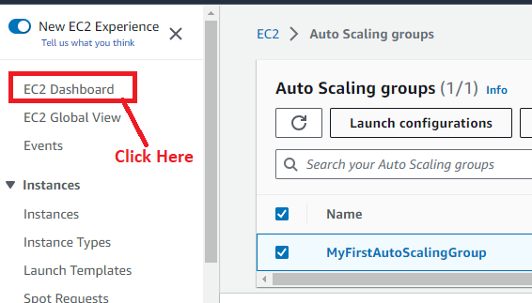

**Step 16: Click** onthe **“Instances (running)”.**

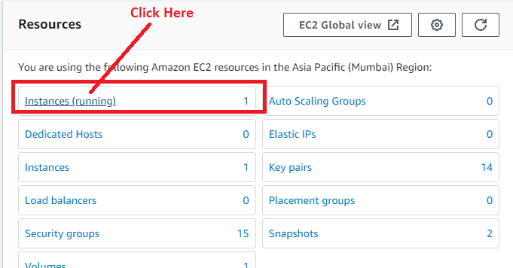

**Step 17: A second instance without name** will be **launched automatically** by **“Auto Scaling Groups”. Select** the **Instance** & **click** onthe **“open address”** inthe **“Public IPv4 Address”.**

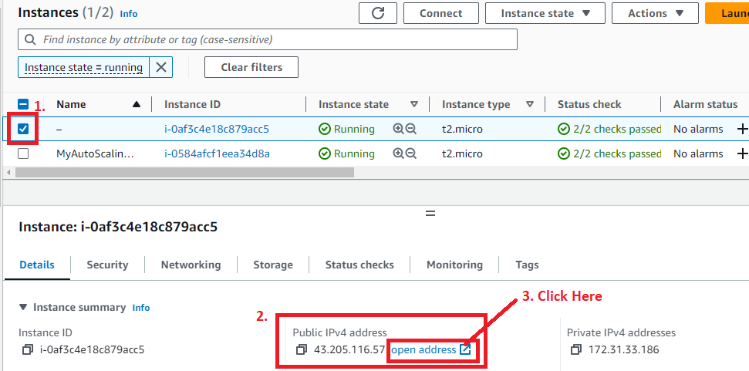

**Step 18: A same web page like** our **EC2 instance** has been **shown to you. This means** our **Auto Scaling Group** is **working fine. Yes, IP** will be **different because** of **new instance creation.**

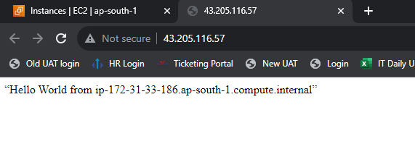

***So, these are the three steps to create & launch the Auto Scaling Group for EC2. We can also do the EC2 instance settings using Launch Template, if we don’t have any AMI available.***